Semiconductor development equipment:
SVT Asccociates MBE reactor:
- 2’’ wafers;
- Clean Antimony-free reactor;
- Group III: In, Ga, Al;
Group V: As cracker, Bi;
Dopants: Si, Be, Te (GaTe)
- III-As;
III-AsBi;
LT-GaAs;

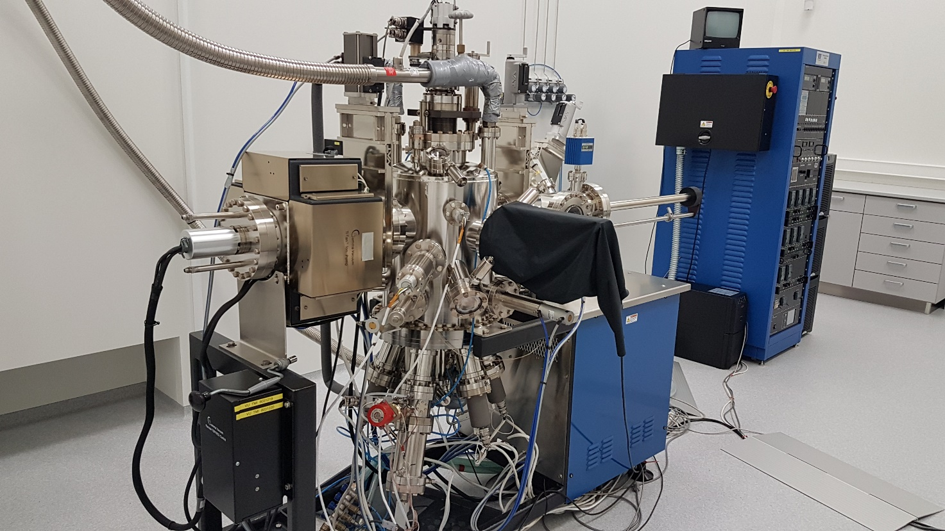
VEECO GENXplor R&D MBE system:
- 3’’ wafers;
- Extremely high composition and thickness accuracy (error <1.5%);
- Group III: In, 2xGa, Al;
Group V: As cracker, Sb cracker, Bi;
Dopants: Si, Be, Te (GaTe)

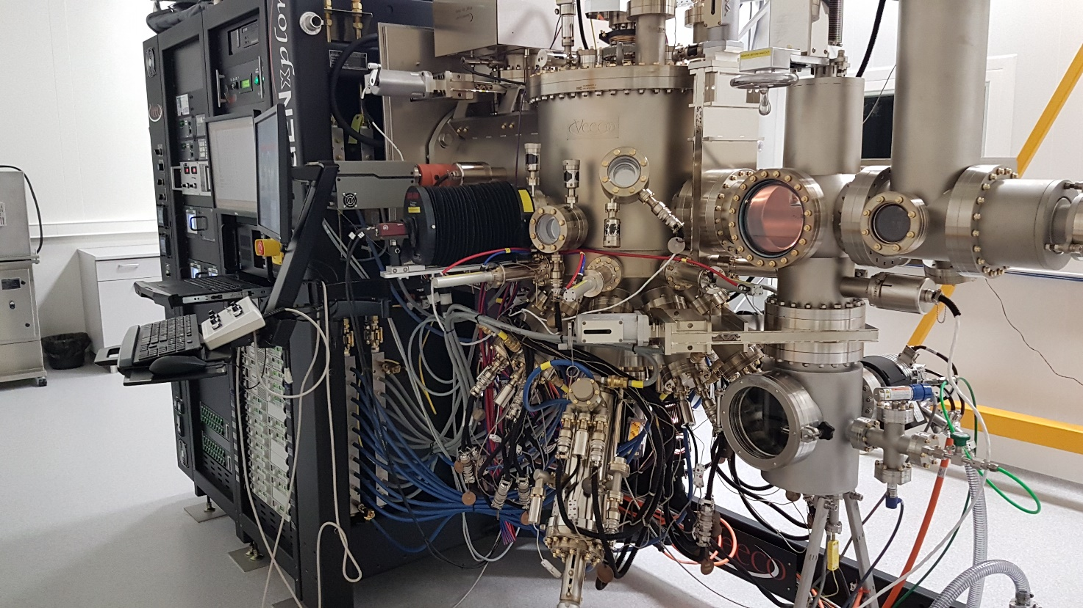
Electron-Beam evaporation station (VST Model TFDS–870):
Electron-Beam evaporation station consists of a glove box and a growing chamber. Firstly, the samples are put in to the “Glove Box”, which is filled with nitrogen gas. The growing chamber is used to grow thin-films of various materials on the samples. Also, this machine is used to grow contacts on the wafers of various materials such as Au, AuGe12%, Ge, Ti, Ni and Al. The maximum diameter of the sample is 2 inches. The wafer holder has four pins to hold the sample. If samples are of smaller dimensions than 2 inches then we can put 4 of them at the same time, but total area should not exceed 2 inches. Also is possible to heat the substrates up to 150 ° C. The sample holder can be rotated (0-28 rpm), which would ensure the uniformity of the coated layer on the sample. Thin-film thickness and deposition rate is controlled with Telemark (Model 880) controller. Parameters: sensor crystal frequency is 6 MHz, resolution Hz (5 MHz – 6 MHz), the measurement speed is 10 measurements/second, accuracy thickness per single count. Most frequently we use 2 A/s deposition rate. Using samples with zinc (Zn) is strictly forbidden!

