TITLE

Name Surname   
*(the name of the presenter must be underlined, and the font of authors' names is Gotham Book 10 pt*)

Center for Physical Sciences and Technology, Department of AAA  
Saulėtekio av. 3, LT-10257 Vilnius, email: [name.surname@ftmc.lt](mailto:name.surname@ftmc.lt)

The abstract for 9th Conference of Doctoral Students and Young Researchers should be in double column (like this example) and ONE page long (use A4 page set-up). Use single spacing 10 pt Gotham Book font (except for the title, which should be in 12 pt Gotham Medium font and in uppercase). Centre the title, the authors’ names, the addresses of institutions and contact email address. Please compose a title that clearly and succinctly describes the content of your work, in order to maximise its impact.

Start each paragraph, except the first, with an indent. Justify the body of the text both left and right. Do not use page numbers. Uniformity of abstract style makes the work much easier to digest!

Use Lithuanian language (or clear English, if one or more of the authors are from abroad) to write your abstract, with an emphasis on describing what is new and why it should attract the attention of the audience., can be used.

References should be made in the end of text after the keywords [1]. Examples of references are shown below. Leave a blank line above the list of references.

Ensure that Figures and Tables have a caption and that they are numbered consecutively. Figures should have dimensions of 1 or 2 columns of text (Fig. 1). Note the size of the character indexes in figures - they should be well legible.

Equations must be numbered at the end of the line. The characters in the equation must have the same magnitude as the text. Note that variables and function symbols are written in *Italic*, while physical constants and differential symbols are written in perpendicular.



References should be made in the end of cited text [1]. Examples of references are shown below. The list shall be numbered in order of appearance in the text [2].

|  |  |  |
| --- | --- | --- |
| Table 1. Types of waveguides. | | |
| Type | *f* (GHz) | Size (mm) |
| S | 2.6 – 4.0 | 72 × 34 |
| C | 5.0 – 7.0 | 40 × 20 |
| X | 8.2 – 12.4 | 23 × 10 |

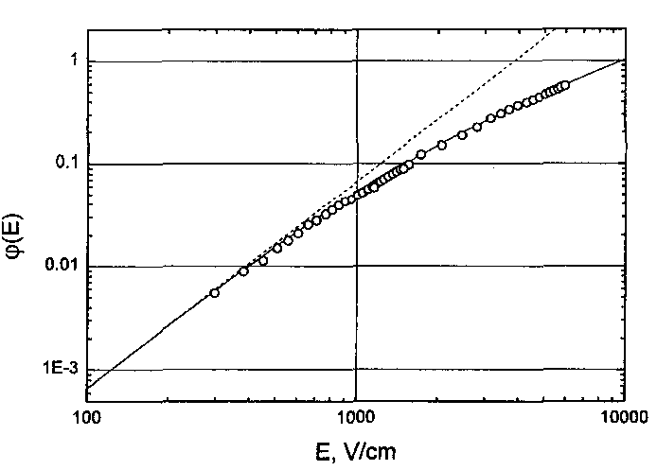

Fig. 1. Figures can be in colour or in black and white.

The abstract should be submitted by email rasa.kromkute@ftmc.lt

The deadline for abstract submission is 11 October 2019.

References

1. [S.G. Lushnikov](http://scitation.aip.org/vsearch/servlet/VerityServlet?KEY=ALL&possible1=Lushnikov%2C+S.+G.&possible1zone=author&maxdisp=25&smode=strresults&aqs=true), [J.-H. Ko](http://scitation.aip.org/vsearch/servlet/VerityServlet?KEY=ALL&possible1=Ko%2C+Jae-Hyeon&possible1zone=author&maxdisp=25&smode=strresults&aqs=true), and [S. Kojima](http://scitation.aip.org/vsearch/servlet/VerityServlet?KEY=ALL&possible1=Kojima%2C+Seiji&possible1zone=author&maxdisp=25&smode=strresults&aqs=true), Appl. Phys. Lett. **84**, 4798 (2004).

2. P. M. Boersenberger, D.S. Weiss, *Organic Pho­toreceptors for Imaging Systems* (New York, Besel, Hong Kong, 1993).