CENTER FOR PHYSICAL SCIENCES AND TECHNOLOGY
Department of Nuclear Research
Isotopic Research Laboratory
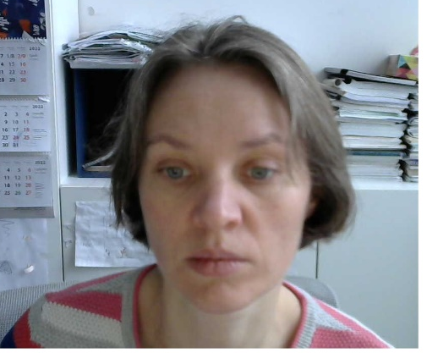
Dr. Rūta Barisevičiūtė
Senior Researcher
Isotopic Research laboratory
ruta.bariseviciute@ftmc.lt

Education:
Bachelor of Physics, Vilnius University, Lithuania. 2000
Master of Physics, Vilnius University, Lithuania. 2002
Ph.D. in Physics, Vilnius University, Lithuania. 2006
Postdoctoral Associate, Institute of Physics, Vilnius Lithuania. 2007-2008
Professional Carrier:
Laboratory Assistant, Faculty of Physics, Vilnius University, Lithuania. 2000-2007
Research fellow, Department of Nuclear Research, Institute of Physics, Lithuania. 2008-2013
Research fellow, Infrared spectroscopy Laboratory, State Scientific Research Institute, Center for Physical Sciences and Technology, Lithuania. 2013-2015
Research fellow, Mass Spectrometry Laboratory, State Scientific Research Institute, Center for Physical Sciences and Technology, Lithuania. 2015-2018.
Senior researcher, Mass Spectrometry Laboratory, State Scientific Research Institute, Center for Physical Sciences and Technology, Lithuania
Traineeship:
2017 09  2000-2007 | International Doctoral Course ‘Stable Isotopes in Forest Ecosystem Research (SIFER)’ at University of Lorraine, France.  Secondment at Maxlab Synchrotron Radiation Facility in Lund, Sweden (week or two yearly).
2005 06 | A week summer courses ‘Nordic Summer School on Synchrotron Radiation’ at Lund University, Sweden.
2004 05-08 and  2004 10 – 2005 01 | Holder of a Marie Curie Fellowship at Wroclaw University, Poland.
2002 01-06 | Studies in Dresden Technical University in the frame of the ERASMUS-SOCRATUS program.

Projects:
2014  2012-2015 | Research project ‘NSSIA: Isotope ecology network in the Baltic Sea region’, funded by Swedish Institute, Baltic Sea Unit.  Research fellow in EU structural fund project ‘Lithuanian Maritime Sector's Technologies and Environmental Research Development’ (Nr. VP1-3.1-ŠMM-08-K-01-019).
2012-2015 | Research fellow in project ‘Water Masses Circulation Features in the Curonian Lagoon, Using Stable Isotope Tags and Finite Element Mode’ (CISOCUR, No. VP1-3.1-ŠMM-07-K-02-086) funded by the European Social Fund under the Global Grant measure.
2012-2014 | Research fellow in project ‘The impact of invasive mollusk D. polymorpha on water quality and ecosystem functioning’ (DREISENA, No. LEK-12023) funded by the Research Council of Lithuania.
2012-2014 | Research fellow in project ‘Chemical munitions search and assessment (CHEMSEA)’ (contract No. MIP-080/2012) funded by the Research Council of Lithuania.
Research Interest:
Isotope ratio mass spectrometry applications in environmental studies (spread of pollution, changes in ecosystems caused by various environmental factors, food webs).
Area of Expertise:
Infrared Spectroscopy, Raman Spectroscopy, Matrix Isolation Technique, Atmospheric Chemistry (Doctoral dissertation ‘Conformational analysis of 1-alkene secondary ozonides’), Stable Isotope Ratio Spectrometry, Aerosol Particles, Food Webs, Carbon Cycle in Aquatic and Terrestrial Ecosystems, Plant Ecology, Sustainable Agriculture.
Links to personal profiles:
https://www.researchgate.net/profile/Ruta-Bariseviciute

