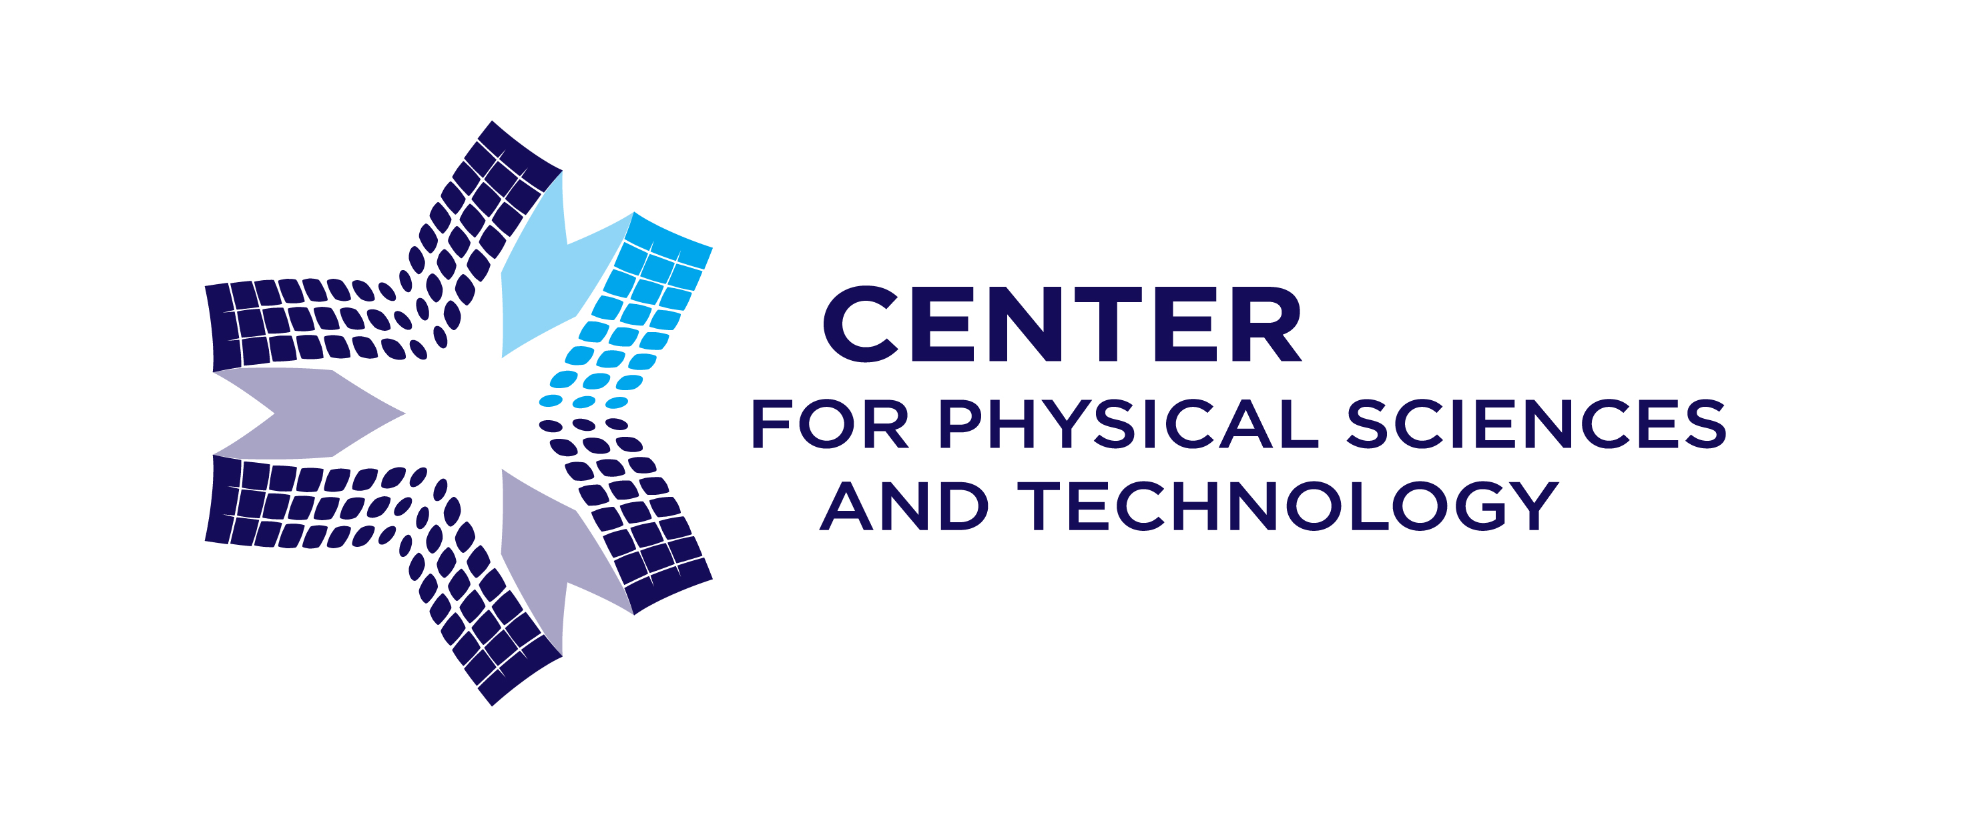CENTER FOR PHYSICAL SCIENCES AND TECHNOLOGY
Department of Nuclear Research
Isotopic Research Laboratory
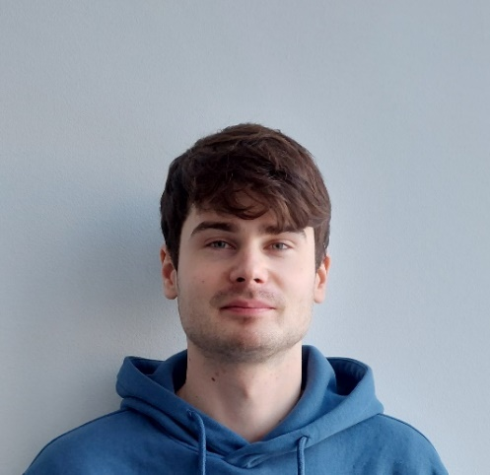
Laurynas Bučinskas
Ph.D. student
Isotopic Research laboratory
laurynas.bucinskas@ftmc.lt

Education:
Bachelor in Physics, (Vilnius University, Lithuania), 2018
Master in Physics, (Vilnius University, Lithuania) 2020
Ph.D. student in Physics, (Vilnius University, Lithuania), 2020-now
Biography:
2018-present Ph.D. student, Physics – N 002. “Sulphur compound dynamics and balance in the environment”, Center for Physical Sciences and Technology;
2018-present Engineer, Atmospheric pollution research laboratory, Center for Physical Sciences and Technology;
2016 to 2018 Technician, Center for Physical Sciences and Technology.
Publications/ projects:
Laurynas Bučinskas is an author and co-author of more than 4 scientific articles in peer-reviewed journals.
Projects:
2020-2023 Junior scientific researcher, Promotion of centers of competence and promotion of innovation and technology transfer centers (Research Council of Lithuania), no. 01.2.2-CPVA-K-703-03-0031, “Tvarios aplinkos vertinimo priemonių ir technologijų kūrimo ir taikymo kompetencijų centras”;
2021-2022 Junior scientific researcher, Funding for technological development projects (Agency for Science, Innovation and Technology), no. TPP-04-001, “Ultra mažų bandinių grafitizavimo sistemos (CORgiS) sukūrimas”.
Research interest:
Stable isotope analysis of carbon and sulfur, isotope ratio mass spectrometry, aerosol particles.
Links to personal profiles:
https://orcid.org/0000-0001-7133-7864
https://www.researchgate.net/profile/Laurynas-Bucinskas

