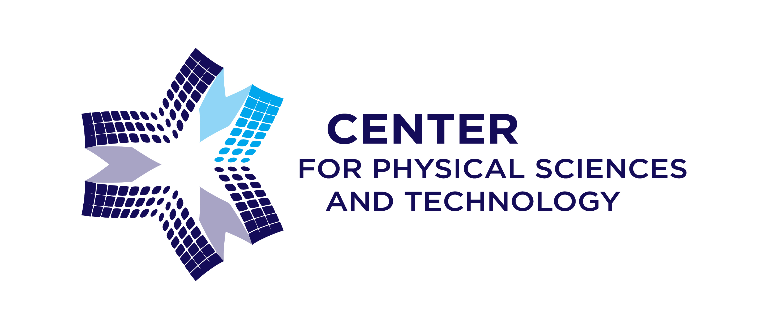CENTER FOR PHYSICAL SCIENCES AND TECHNOLOGY
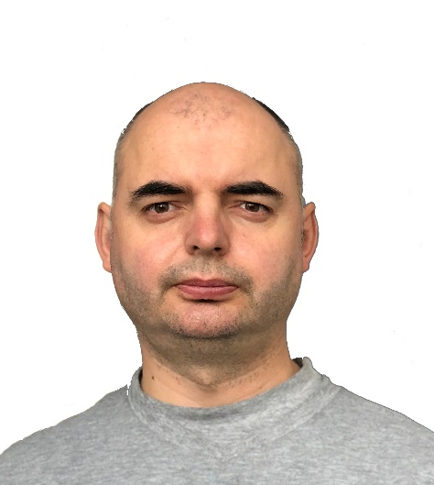
Department of Nuclear Research
Isotopic Research Laboratory

Dr. Andrius Garbaras
Senior Researcher
Head of Isotopic Research laboratory
andrius.garbaras@ftmc.lt

Education:
Bachelor in Physics and qualification of teacher of Physics, (Vilnius University, Lithuania), 2002
Master in Physics, (Vilnius University, Lithuania) 2004
Ph.D. in Physics, (Vilnius University, Lithuania), 2011
Biography:
Andrius Garbaras is a Senior Researcher at FTMC where he is working since 2004. He completed his Ph.D. at the Institute of Physics (in 2011), and currently leading Isotopic Research Laboratory at the Center for Physical Sciences and Technology.
Publications/ projects:
Andrius Garbaras published more than 60 scientific articles in peer-reviewed journals (Scientific reports, Environmental Sciences and Technology, and others). He was leading international projects, and supervised bachelor, master and doctoral-level students.
Teaching:
Mass spectrometry (Master level course)
Technology risk assessment and management (bachelor level course)
Research interest:
Isotope ratio mass spectrometry applications in forensics, ecology, archeology, and geology.
Area of Expertise:
Environmental Sciences, Aerosol particles, Materials origin identification.
Links to personal profiles:
https://orcid.org/0000-0002-3105-8059
https://www.researchgate.net/profile/Andrius-Garbaras

