CENTER FOR PHYSICAL SCIENCES AND TECHNOLOGY
Department of Nuclear Research
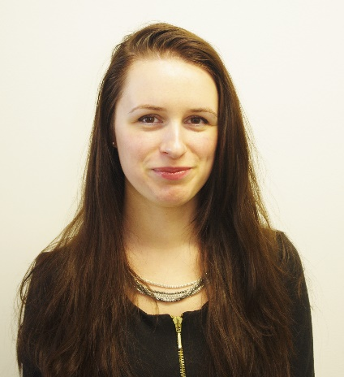
Isotopic Research Laboratory

Dr. Raminta Skipityte
Researcher
Isotopic Research laboratory
raminta.skipityte@ftmc.lt

Education:
2010 Bachelor in Ecology and Environmental Sciences (Vilnius University)
2012 Master in Ecology (Vilnius University)
2022 Ph.D. in Ecology (Vilnius University)
Biography:
I studied Ecology in Vilnius University, Faculty of Natural Sciences, and started using stable isotopes since my bachelor studies. I defended my Ph.D. in Ecology in Nature Research Centre, title “Dietary aspects of human and animal palaeoecology: stable isotope data”.
I am a junior research fellow in Isotopic Research Laboratory, before technician in Mass Spectrometry Laboratory at Center for Physical Sciences and Technology.
During that time I participated in more than five national and international projects (National scientific research program, Open partnership research projects, IAEA Coordinated research projects).
Publications/ projects:
I am an author and co-author of more than 15 scientific articles in the peer reviewed journals such as Biogeosciences, Science of the Total Environment, Isotopes in Environmental and Health Studies, Animals, American Journal of Physical Anthropology, Archaeological and anthropological sciences, etc..
Research interest:
Stable isotopes are in everything and everywhere, thus I am interested in finding creative ways to solve various environmental issues using stable isotope ratio method. I am mostly interested in fields of ecology and environmental studies, food webs and nutrition, animal ecology, palaeodiet, food quality. My experience and knowledge allow me to do many things starting from primary study design, samples selection and collection, preparation and measurements in the lab as well as stable isotope data interpretation.
I apply stable Isotope Mixing Models Using SIBER, SIAR, MixSIAR in my studies.
Traineeship :
I got the scholarships for internships at Ludwig-Maximilians-University (LMU) Munich, Germany (DAAD scholarship), at Stockholm University, Stockholm, Sweden (Visby scholarship). I also participated in International Doctoral Course “Stable Isotopes in Forest Ecosystem Research (SIFER)” at University of Lorraine, France. I also periodically participate in online courses and workshops.
Links to personal profiles:
https://orcid.org/0000-0002-2141-1859
https://www.researchgate.net/profile/Raminta-Skipityte

